Daye:18-12-23

PYTHON ASSIGNMENT-7

INHERITANCE:

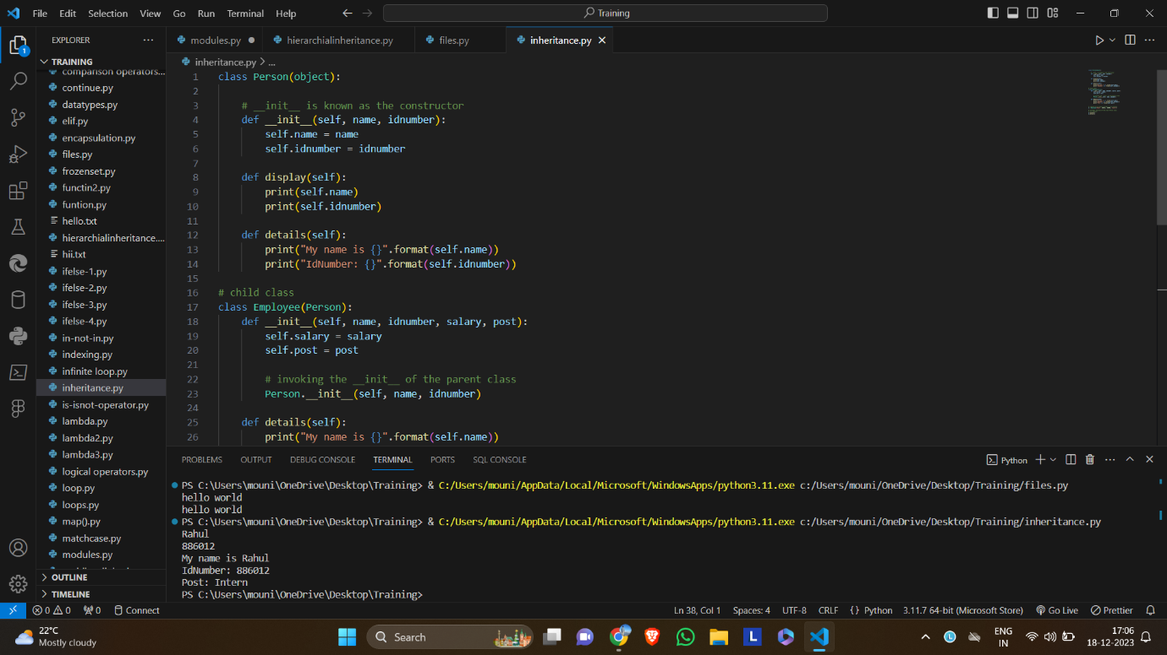

MULTILEVEL INHERITANCE:

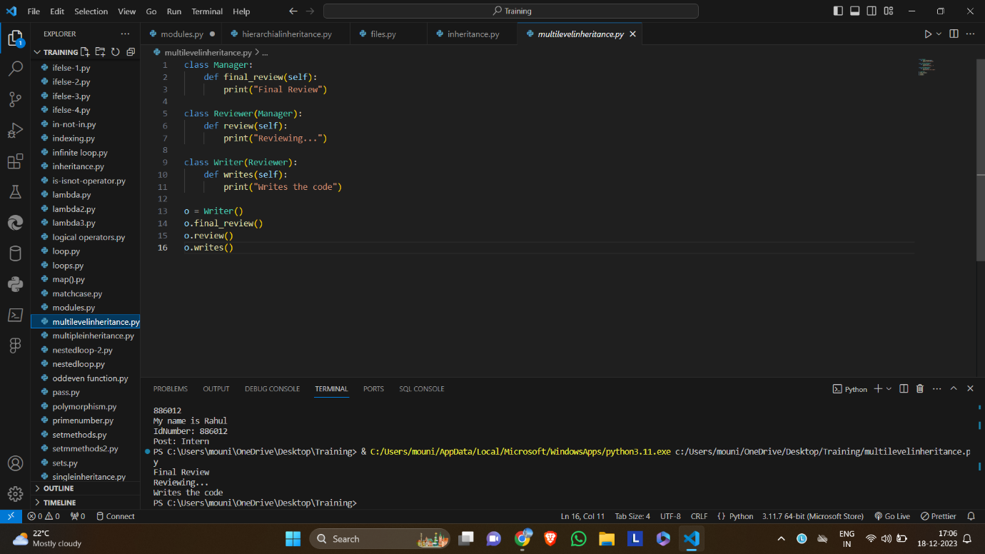

MULTIPLE INHERITANCE:

HIERARCHIAL INHERITANCE:

ENCAPSULATION:

POLYMORPISM:

EXCEPTIONS:

FILE HANDLING:

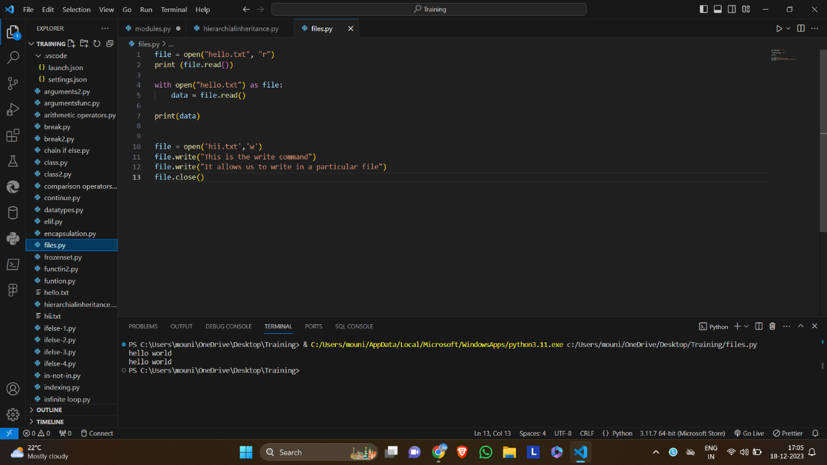

MODULES:

